1. Welcome, aspiring student! This is where your learning REALLY starts. Have you ever heard of a Unimon?

Yes – skip to part 2.

No? Well, I can help with that. You have 25 wit points at the start of each battle, and you should keep these about you or you lose! Unimon are your new best friends; They will help you in to learn and most importantly, outsmart the other students. Here in Queen’s, your ability to outsmart is key, and there is no better way to show your own knowledge than through your prowess with Unimon! Despite existing in cards, these critters are very much here and alive. Don’t get too excited to outsmart people yet, there’s still plenty to learn!

2. So you wanna be the big shot around here? You wanna do the outsmarting, without all the outsmarted business. No problem. I’ll show you how, but only you can make it happen. What would you like to hear about? Or, if you already know ALL this, skip on to part 3!

1. Super Epic Battle Monster Cards!
2. The Playing field
3. The Basics
4. How to win
5. **Super Epic Battle Monster Cards**

There are three types of cards you should learn, young ‘un. The first, and most important, are your Unimon of course! These little critters are your sword and shield, defending your wit like no other! Below is an example Unimon Card!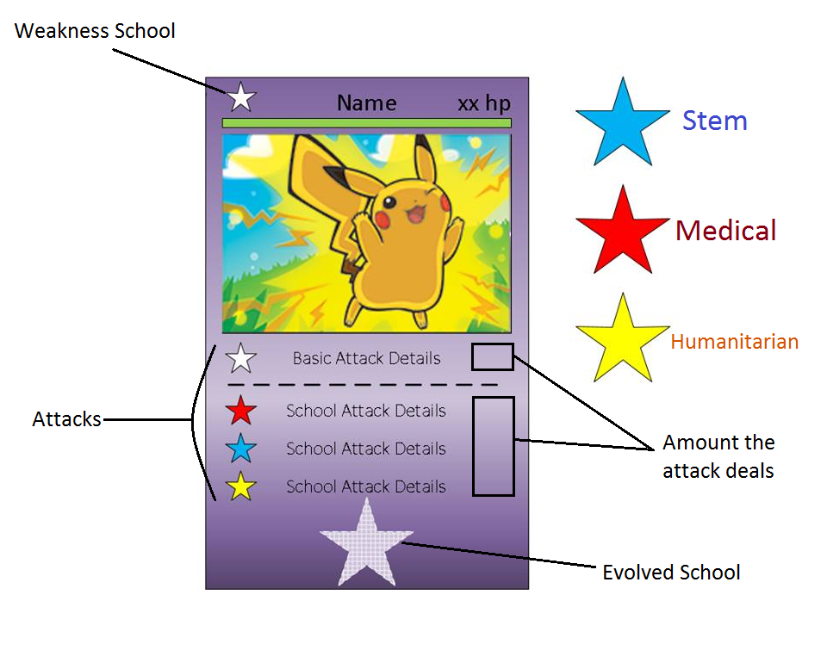

Unimon cards are easy, and there’s a simple cycle to learn! Humanitarian deals +20 damage to stem, and 10 damage to medical. Medical deals +20 damage to Humanitarian, and 10 damage to Stem. Stem deals +20 damage to medical, and 10 damage to Humanitarian. Simply have enough intellect to defeat the other unimon and you’ll be outwitting everyone in no time!

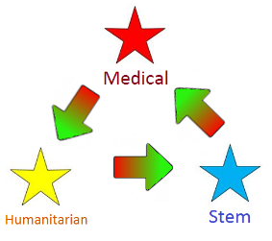

The second type of card is a School card. This is simply a card relating to either Stem, Humanitarian or Medical. You do not need any school cards to power a basic attack. However, to use an evolved attack you’ll always need a school card of the appropriate school to power that evolved ability. Your school cards power these abilities, but once a school card is used it is discarded to the graveyard. So use your powers wisely! These cards can also be used to evolve your Unimon, you can evolve one Unimon per turn. Once you have used a card to evolve an active Unimon, your turn is ended however you can still use the school card on your next turn to have that Unimon attack. Once you have used a school card for an attack it must be discarded. Unimon can be evolved in your bench without ending your turn.

**b. The Playing Field:**

There are 5 important parts to your playing field, as demonstrated in the picture below:

1. The Deck: Your cards sit here in a pile face down. This is where you will draw your cards from e.g. at the end of your turn if you have used a card during that turn, you will draw a new card from this pile to refill your deck. In the event items need to be returned to your deck, such as you chose to discard an unwanted card and draw another in it’s place, you must shuffle your deck again.
2. Your Hand: Your hand will always have 5 cards by the end of your turn. These are for your eyes only, and allow you to strategize against your opponent. It is from from these cards that you may move a card to your bench or active slot. If your hand isn’t as you need it, you always have the option to reshuffle 1 card into your deck and draw a new card in its place at the end of your turn.
3. The Bench: This can hold 3 cards. When playing a card from your hand to the bench, you place the card faceup. Each turn, you may only place one card from your hand to your bench. They cannot be returned to your hand once placed. These can have stats added to them from other Unimon Abilities, and you can also evolve a Unimon on the bench, however Unimon can not attack from the bench. The school card used to evolve a benched unimon stays with that unimon, and so can be used to power a evolved special ability when that unimon becomes active.
4. The Active Slot: The card in this slot is the only one that can use to outwit the opponent’s Unimon, and who could ultimately end up losing you wit points (which are you player’s ‘health’ points). This card can be evolved, have school cards attached and attack (though this will end your turn!). You may only have one card active at any time, and retreating this card will cause a wit points penalty -1. You must always have an active card. Your players total wit points at the start of a battle is 25, and you have only won the battle when your opponent's wit points reach 0. Defeating an enemy unimon will remove 3 wit points from your opponent, but the same can also happen to you!

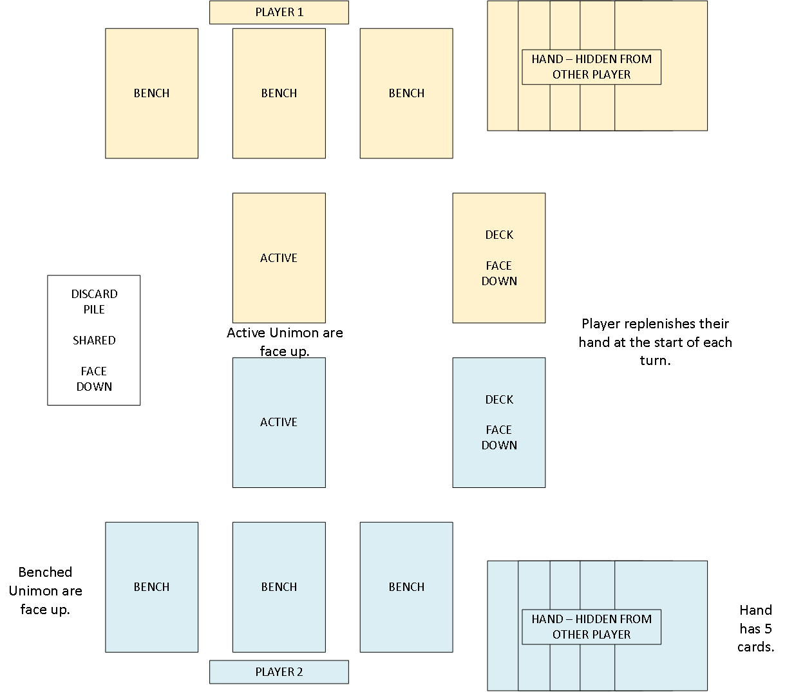

**c. The Basics**

There will be 50 unimon cards (2 of each unimon) and 60 school cards (20 of each school). These should be split into a unimon pile and a school pile, and these two piles should be evenly and randomly split between the two players (25 unimon cards, 30 school cards per player). This leaves each player with a deck of 55 cards each with a nice assortment of school cards and unimon cards, which you can then use to fill your hand.

The game begins with you and your opponent drawing 5 cards. These go on your bench. If you get no Unimon in your first draw, you simply show your opponent your cards, then reshuffle them back into your deck until you do. No point trying to outsmart anyone without Unimon!

On the first turn of your round, you can move as many cards as you wish to your bench, and declare them active on the same round (face down this time). You must also choose a school star without showing your opponent. Once you are happy with your benched and active Unimon, both you and your opponent turn their active card face up and reveal your school star. Whoever has the counter to the other person’s school star gets to go first (if they’re both the same, keep picking counters until one of you win!). From here onwards, the active card will always be face up.

You cannot use a Unimon the turn that you put it into the active space; that’s just unfair! You may only have one active Unimon at any given time and it acts as a temporary shield to your own wits, but unfortunately this comes with the drawback of your Unimon now being targetable! To use one of your Unimon’s specialized abilities, you need to place the appropriate school card under them, and after using the ability the school card should be discarded to the graveyard.

**d. How to Win**

At the start of a battle, your player has 25 wit points. They lose 3 wit points if one of their Unimon is defeated and 1 wit point for retreating the active Unimon. The same goes for your opponent. You defeat your opponent by defeating their unimon, until the player is outwitted and their wit points reach 0!

To defeat your opponents Unimon, you must try to strategize against them by evolving your Unimon to a school that is the counter to your opponents’ Unimon. However, as you will come to find out, this can be difficult! Place damage counters on your Unimon in a stack to denote how much damage has been dealt. Once the Unimon’s health drops to 0, you must indicate this in your wit points. Don’t forget about how school’s affect your Unimon’s attack, so chose wisely as each unimon will have a different ability for each school!

You are now ready to start your Super Epic Learning Monster Fighters journey - good luck!

**Differences between card game and android game**

There are some parts our card game that do not accurately portray our android game. Any changes between the two games are listed below:

* In the android game, you start off with a set number of Unimon and have no knowledge of their evolutions. You must unlock an evolution before being able to play it.
* Damage tokens will not be a part of the android game. Any damage/stat supplement will be displayed on the card itself as the new HP.
* After defeating a player in the android game, you get to choose one of their evolutions to learn. This is considered your prize card.
* The android game has school-evolve cards. These cards can be placed on any Unimon on the playing field to evolve them in place of school cards evolving them.
* In the android game, you will progress to different levels through a game map which will allow you to battle a new opponent (it is desirable to have a free roaming map).
* As you progress through the game, new opponents will have higher wit points adding more challenge to the game.
* The shuffling of cards at the start of the game will be controlled so that at least one playable unimon is dealt.